3D Reconstruction: Scaling, Rotation and Dimension Verification
COLMAP point cloud — assignment results

1. Reference object and input
The reference object is the framed picture in images/1.jpg. Its known outer dimensions are 17.5 cm wide and 23.0 cm high. The input reconstruction is D:\CV5570\CV5570_3D_Reconstruction_Assignment\Set 2\dense\0\fused.ply, containing 1,455,681 points.
Chosen width axis: Y; chosen height axis: X.
Calculated uniform scale: 5.1835198967 cm per original PLY unit.

2. Transformation matrices
Scaling matrix S (4 × 4):
[[5.1835199 0. 0. 0. ]
[0. 5.1835199 0. 0. ]
[0. 0. 5.1835199 0. ]
[0. 0. 0. 1. ]]
Rotation matrix Rx(45°) (4 × 4):
[[ 1. 0. 0. 0. ]
[ 0. 0.70710678 -0.70710678 0. ]
[ 0. 0.70710678 0.70710678 0. ]
[ 0. 0. 0. 1. ]]
Combined homogeneous transformation T = Rx @ S:
[[ 5.1835198967 0. 0. 0. ]
[ 0. 3.6653020694 -3.6653020694 0. ]
[ 0. 3.6653020694 3.6653020694 0. ]
[ 0. 0. 0. 1. ]]
Using column vectors, p′ = T p. Uniform scaling is applied first, followed by a 45° rotation about the X-axis around the origin. Rotation preserves Euclidean distances.

3. Dimension verification (±5% tolerance)
Dimension | Actual (cm) | Reconstructed (cm) | Abs. error (cm) | Error (%) | Result
Width | 17.500 | 18.024 | 0.524 | 2.99% | PASS
Height | 23.000 | 22.582 | 0.418 | 1.82% | PASS
Overall tolerance result: PASS (both dimensions must be within ±5%). The scale is a single uniform least-squares fit to both dimensions; errors are reported honestly and are not forced to meet the tolerance.

4. Visual comparison
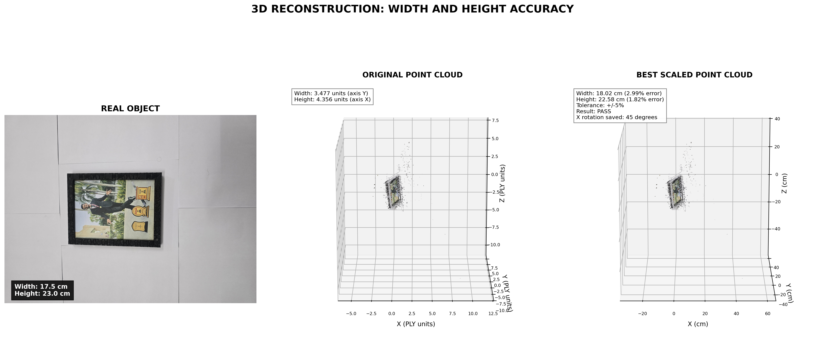
Figure: original photograph, original reconstructed point cloud, and scaled point cloud with the measured width/height errors and ±5% tolerance status.

